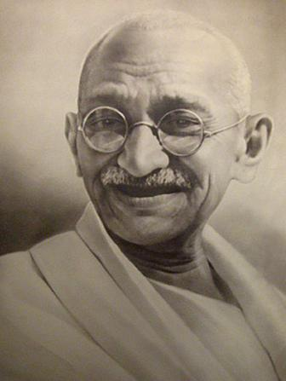
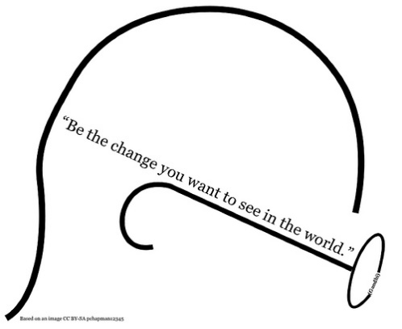

Keep your thoughts positive because…
Your thoughts become your words.
Keep your words positive, because…
Your words become your behaviours.
Keep your behaviours positive, because…
Your behaviours become your habits.
Keep your habits positive, because…..
Your habits become your values.
Keep your values positive, because….
Your values become your destiny.

